***Departmental Achievements***

* *Academic Achievements*

1. **Payosnee Mani**

* Scored ***9.14 SGPA*** ***(College Topper)*** in U.G. 2nd Semester Examination, 2024
* Selected for the “Minor in Artificial Intelligence Program” in ***IIT Ropar*** by scoring 88.70 Percentile in the year 2024

1. **Arkarprava Roy**

* Scored ***9.42 SGPA*** ***(College Topper)*** in U.G. 1st Semester Examination, 2024
* Registered for the 4 –weeks course ***“Introduction to Probability and Statistics”*** conducted by **NTPEL**
* Certified for active participation in a 5-day online training program on **"Applications of Python & R Programming,"** organized by **NIT Warangal**, held from January 27th to 31st, 2025.
* *Co-curricular / Extra - curricular Achievements*

1. **Atithi Rai**

* First Prize Winner - Recitation Competition (X-travaganza, 2025)

1. **Sumit Abhishek Beck**

* Second Prize Winner - Intra College Football Tournament (Annual Sports -2025)

1. **Priyanshu Linda**

* Second Prize Winner - Intra College Football Tournament (Annual Sports -2025)
* *Faculty Achievements*
* Fr. Dhivviyanandam Irudayaraj, S.J. awarded PhD in Mathematics in the year 2024
* Ms. Swarnali Datta qualified 26th WB-SET 2024
* Mr. Tushar Das selected as a member of Board of Studies of Department of Statistics, University of North Bengal

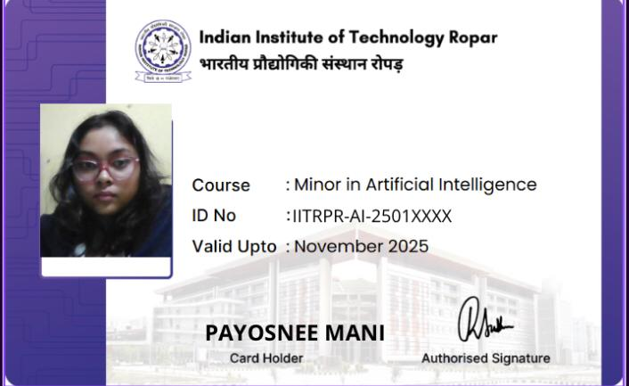

1. **Payosnee Mani**

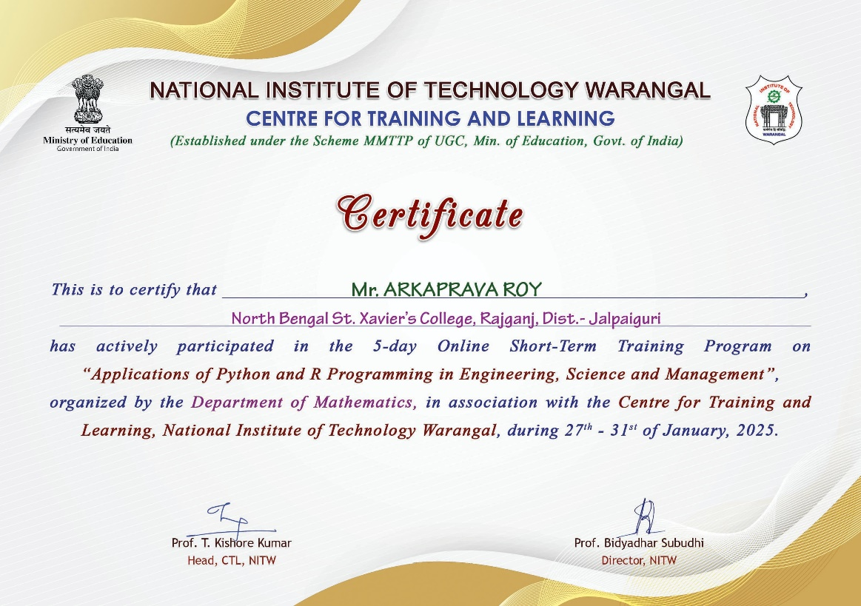

1. **Arkaprava Roy**

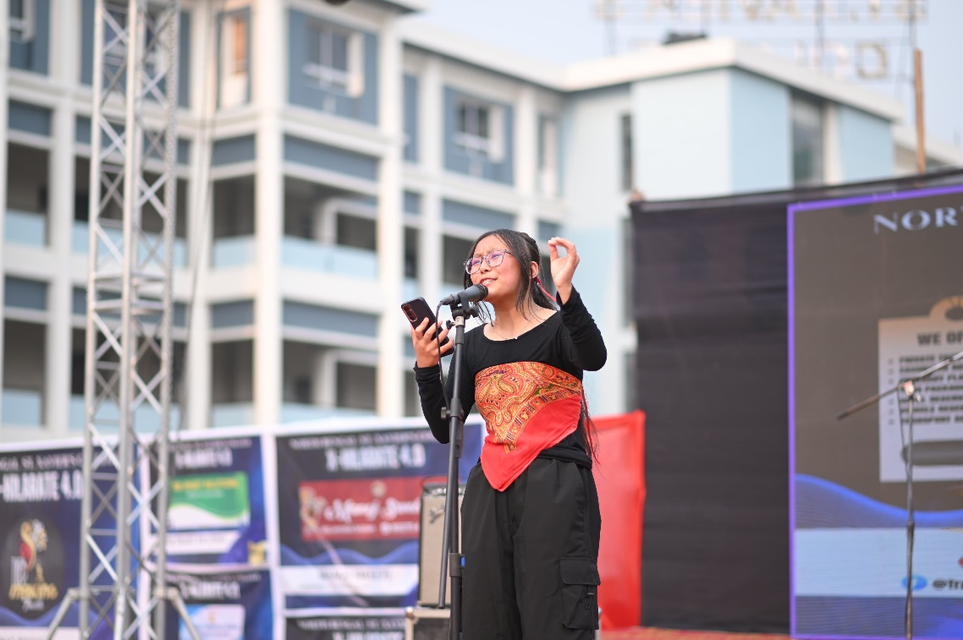

1. **Atithi Rai**

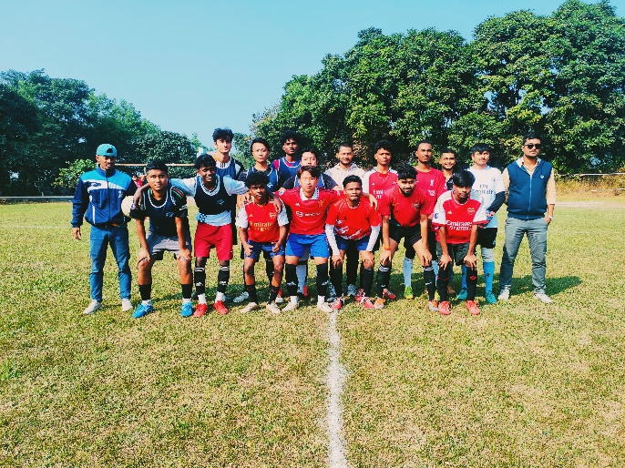

1. **Sumit Beck**
2. **Priyangshu Linda**